**ATTENDANCE MANAGEMENT SYSTEM**

**A MINI PROJECT REPORT**

**18CSC207J - ADVANCED PROGRAMMING PRACTICE**

***Submitted by***

# SAI SHARMILI [RA2111003011024]

**MADAN PRASAD S [RA211100301006]**

**K. BHARGAVI[RA2111003011931]**

*Under the guidance of*

# Nithiya S

Assistant Professor, Department of Computing Technologies ***in partial fulfillment for the award of the degree***

***of***

## BACHELOR OF TECHNOLOGY

in

**COMPUTER SCIENCE & ENGINEERING**

of

## FACULTY OF ENGINEERING AND TECHNOLOGY



S.R.M. Nagar, Kattankulathur, Chengalpattu District

**MAY 2023**

# SRMINSTITUTEOFSCIENCEANDTECHNOLOGY

(Under Section 3 of UGC Act, 1956)

## BONAFIDE CERTIFICATE

Certified that Mini project report titled **ATTENDANCE MANAGEMENT SYSTEM** is the bona fide work of **SAI SHARMILI (RA2111003011024.) MADAN PRASAD S (RA2111003011006)** and **K. BHARGAVI (RA2111003011931)** who carried out the minor project under my supervision. Certified further, that to the best of my knowledge, the work reported herein does not form any other project report or dissertation on the basis of which a degree or award was conferred on an earlier occasion on this or any other candidate.

|  |  |
| --- | --- |
| **SIGNATURE** | **SIGNATURE** |
| Mrs. Nithiya S  **GUIDE**  Assistant Professor  Department of Computing  Technologies | Dr. M. Pushpalatha  **HEAD OF THE DEPARTMENT**  Professor & Head  Department of Computing  Technologies |

## TABLEOFCONTENTS

|  |  |
| --- | --- |
| **ABSTRACT** | **1** |
| **TABLE OF CONTENTS** | **2** |
| **1 INTRODUCTION** | **3** |
| **2 LITERATURE SURVEY** | **4** |
| **3 SYSTEM ARCHITECTURE AND DESIGN** | **5** |
| **4 METHODOLOGY** | **6** |
| **5 CODING AND TESTING** | **7** |
| **6 SCREENSHOTS AND RESULTS** | **10** |
| **7 CONCLUSION AND FUTURE ENHANCEMENT** | **12** |
| **REFERENCES** | **13** |

## ABSTRACT

With the continuous growth of the digital world, we are becoming increasingly dependent on a vast range of digital applications. The main concern in many instances is that access to these applications should be secure and authenticated. Our attendance management system is a computer-based software application that allows organizations to record and track the attendance of their employees or students. The system provides a convenient and efficient way to monitor attendance, generate reports, and manage employee or student information. The software typically includes features such as biometric or card-based authentication, real-time tracking of attendance, automated notifications, and integration with payroll or academic systems. The implementation of an attendance management system can help organizations to improve their productivity, reduce manual errors, and ensure compliance with attendance policies.

In addition to the basic functionalities mentioned above, attendance management systems can also offer advanced features such as leave management, time-off requests, shift scheduling, and performance tracking. These features help organizations to streamline their administrative tasks, automate repetitive processes, and reduce paperwork.

Moreover, attendance management systems can provide real-time insights into employee or student attendance patterns, which can help organizations to identify trends and make informed decisions about staffing, scheduling, and resource allocation. The system can also assist in monitoring employee or student behaviour and detecting any instances of absenteeism or tardiness. Overall, attendance management systems are a valuable tool for organizations seeking to optimize their operations and improve their overall efficiency.

**CHAPTER 1** INTRODUCTION

An attendance management system is a computer-based software solution designed to help organizations track and manage the attendance records of their employees or students. The system provides a digital method of recording and monitoring attendance, eliminating the need for manual record-keeping and reducing the risk of errors or inaccuracies. By automating attendance management, the system enables organizations to optimize their operations and improve their overall efficiency.

The use of attendance management systems is becoming increasingly popular across a wide range of industries, including education, healthcare, manufacturing, and hospitality. These systems offer a range of features and functionalities that enable organizations to manage attendance data efficiently and effectively.

Attendance management systems typically provide a range of features, including biometric or card-based authentication, real-time tracking of attendance, automated notifications, and integration with payroll or academic systems. Some advanced systems may also offer features such as leave management, time-off requests, shift scheduling, and performance tracking. By providing a comprehensive set of features, attendance management systems can help organizations to automate and streamline their attendance tracking process, freeing up valuable time and resources for other important tasks. Additionally, the use of attendance management systems can help organizations to reduce costs associated with manual record-keeping and improve the accuracy and reliability of attendance data.

The implementation of an attendance management system can help organizations to improve their workforce management, ensure compliance with attendance policies, and reduce administrative burden. The system can also provide real-time data insights into attendance patterns, which can help organizations make informed decisions about staffing, scheduling, and resource allocation.

Overall, attendance management systems are an essential tool for organizations looking to streamline their attendance tracking process, improve their operational efficiency, and optimize their workforce management.

**CHAPTER 2**LITERATURE SURVEY

**In [1] IOT-Based Cloud Integrated Smart Classroom and Sustainable Campus [2021]:**

This paper proposed an idea of recording attendance using the face recognition technique and storing the data using IoT. In this method, Arduino Uno is used as a microcontroller. Cameras are used to detect the face of an individual or group of pupils. Based on the information that is stored prior, the faces are recognized and the attendance is recorded and the database is obtained. This method provides better results in a short span of time but fails to produce the most accurate results.

There are some chances of some errors.

**In [2] Attendance Management System through Fingerprint [2018]:**

This paper proposed an idea of recording attendance using biometrics (fingerprint) for tracking attendance and storing the data using LAN. This paper provides a brief description of the usage, accessibility, accuracy, affordability and acceptance of the biometric (fingerprint verification) system. In this system, the data is fetched from the individual in the form of a fingerprint and then it is verified with the data that was stored prior and marks the attendance of an individual. Finally, the database is also obtained. This method provides high-accuracy results and consumes less time but it is not cost-effective

**In [3] Efficient access control system based on aesthetic QR code [2018]:**

The idea of granting access based on QR code detection is proposed. In this method, the QR code will be checked and if it matches with the stored data then the access is provided for the user or else the access will be denied. This method is well suitable for residential purposes and provides better safety and security. In this method, the database is not collected and it is less secure than other modern methods.

**In [4] Student attendance system in the classroom using face recognition technique [2016]:**

Here this paper gives an idea of recording attendance using face recognition technique. Also, this paper provides a detailed description of the results and the analysis obtained from this method. Faces are recognized using cameras and the verification is done. Then the attendance is marked. This method is suitable only for a moderate number of people and the results obtained are nearly 87% accurate. This method fails to recognize people in bulk quantity and causes errors in results.

**In [5] Student Attendance Management System [2018]:**

The system is a Web-based application developed for daily student attendance in departments within the university. It facilitates access to the attendance of a particular student in a particular class. This system will also help in generating reports and evaluating the attendance eligibility of a student. The system is not only improving the work efficiency, students’ study and development, but also can save human and material resources.

**CHAPTER 3**

### SYSTEM ARCHITECTURE AND DESIGN

The system architecture and design for an Attendance Management System can be broken down into several key components, including hardware, software, and database.

* **Hardware:** The system may require biometric or card-based attendance trackings devices, such as fingerprint scanners, facial recognition cameras, or RFID card readers. These devices are used to capture attendance data and transmit it to the software system.
* **Software:** The software component of the system architecture includes the attendance management software application, which is responsible for processing and storing attendance data. This software should be designed to be scalable and adaptable to the specific needs of the organization. The software should also include a user-friendly interface to enable easy access and management of attendance data.
* **Database:** The database component of the system architecture is responsible for storing and managing the attendance data. This database should be designed to be highly reliable, scalable, and secure. The database should also be able to handle large volumes of data and provide fast access to attendance records for reporting and analysis.
* **Reporting:** The reporting module generates reports based on the attendance data stored in the database. The reporting module should be customizable and should provide various types of reports such as daily attendance reports, monthly attendance reports, and absenteeism reports.
* **Integration:** The integration module allows the attendance management system to integrate with other systems such as payroll or academic systems. This module should be designed to be flexible and adaptable to various integration requirements.
* **Security:** To ensure data security, the system should implement various security measures such as data encryption, access controls, and user authentication. The attendance management system should only allow authorized users to access the system and the data, and the system should be designed to protect against various types of attacks such as malware, phishing, and hacking.

In addition to these key components, the system architecture may also include various modules and integrations, such as analytics modules, integration with payroll or academic systems, and mobile or web-based access for users. The system should also be designed to comply with various data privacy regulations such as GDPR and HIPAA. The system should protect the privacy of personal information by implementing measures such as data anonymization, consent management, and secure data storage.

Overall, the system architecture and design for an Attendance Management System should be carefully planned and executed to ensure that it meets the specific needs and requirements of the organization. The system should be designed to be reliable, scalable, and secure, and should provide accurate and timely attendance data to enable effective workforce management.

**CHAPTER 4**

### METHODOLOGY

The methodology for developing an Attendance Management System typically involves several steps, each of which plays an important role in ensuring the successful development and deployment of the system. The following are the typical steps involved in the development of an Attendance Management System:

* **Requirements Gathering:** This is a crucial step in the development process, as it involves identifying the specific needs and requirements of the organization. This can involve conducting interviews with managers, supervisors, and employees, as well as reviewing existing attendance data to identify areas for improvement. The goal is to gather as much information as possible about the organization's attendance tracking needs so that the system can be designed to meet those needs.
* **System Design:** Once the requirements have been gathered, the system architecture and design can be developed. This involves creating a detailed plan for the system that outlines the hardware, software, and database components, as well as the user interface, authentication mechanisms, and reporting modules. The system design should be based on the specific needs and requirements of the organization, as identified in the requirements gathering phase.
* **Implementation:** With the system design in place, the system can be developed using programming languages and software tools. This involves writing code to implement the various components of the system, integrating the hardware components such as biometric scanners or RFID card readers, and testing the system as it is being developed. It's important to follow best practices for software development during this phase to ensure that the system is reliable, efficient, and easy to maintain.
* **Testing:** Once the system has been developed, it must be thoroughly tested to ensure that it functions correctly and produces accurate attendance data. This involves various types of testing, including unit testing, integration testing, and system testing. The goal is to identify any bugs or errors in the system and fix them before the system is deployed.
* **Deployment:** After the system is tested and any bugs have been fixed, it can be deployed in the organization. This involves installing the hardware and software components, configuring the system to meet the specific needs of the organization, and training users on how to use the system. It's important to ensure that the system is fully operational before deploying it in the organization to minimize any disruptions to the organization's operations.
* **Maintenance and Support:** After the system has been deployed, it requires ongoing maintenance and support to ensure that it continues to function correctly. This involves regular updates and bug fixes, as well as user support and training. It's important to have a plan in place for maintaining and supporting the system to ensure that it continues to meet the needs of the organization over time.

Overall, the development methodology for an Attendance Management System involves a structured approach to developing a reliable and effective system that meets the specific needs and requirements of the organization. Each step in the process is critical to the success of the system, and careful attention must be given to each step to ensure that the system is developed and deployed successfully.

### CHAPTER 5 CODING AND TESTING

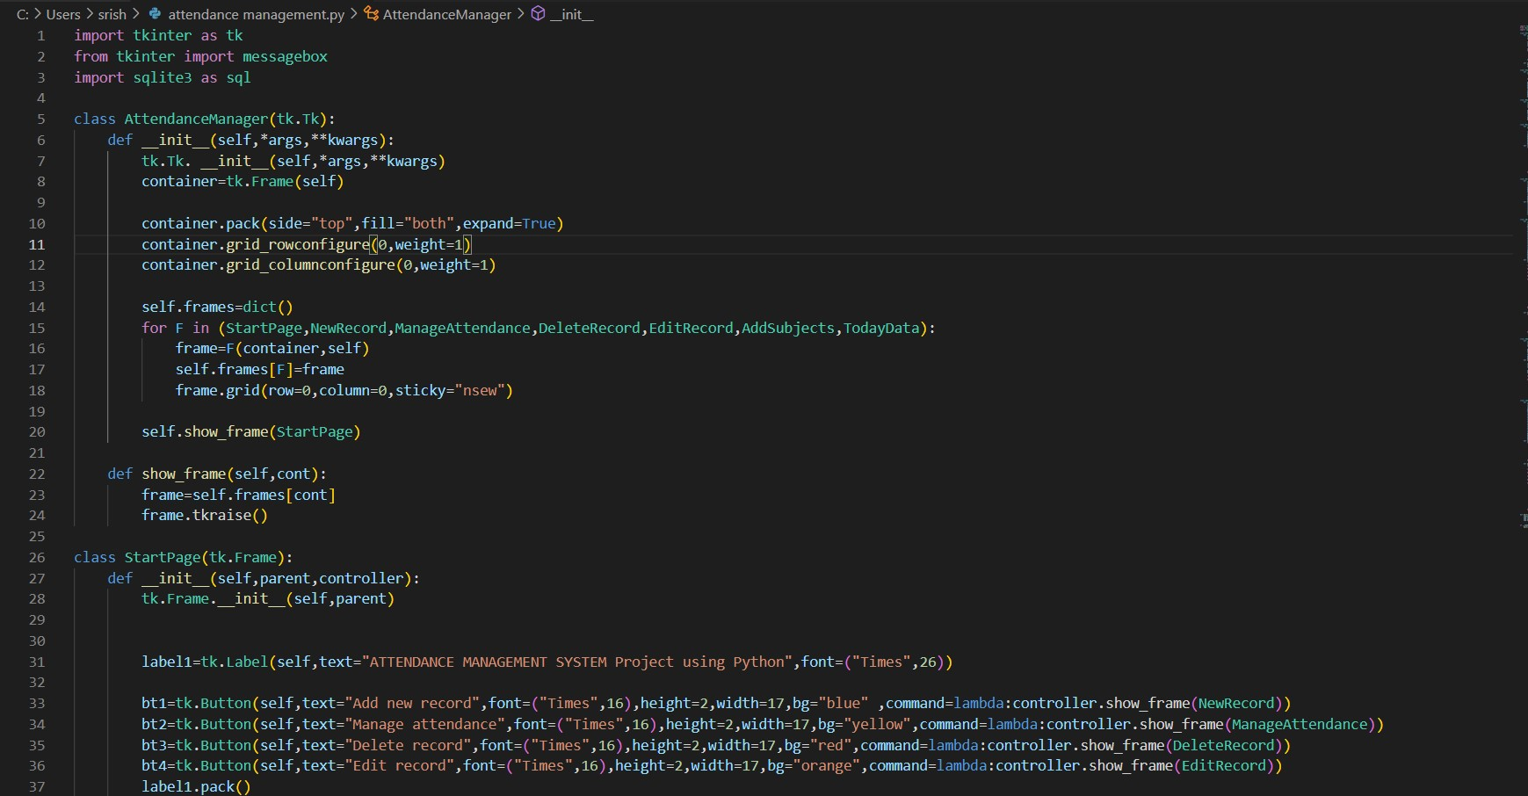

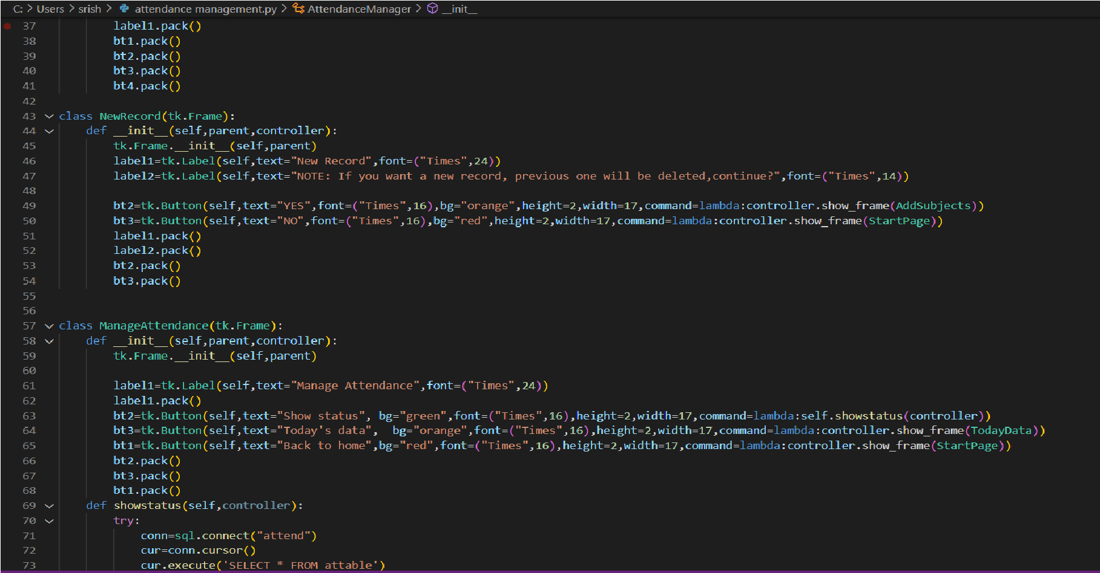

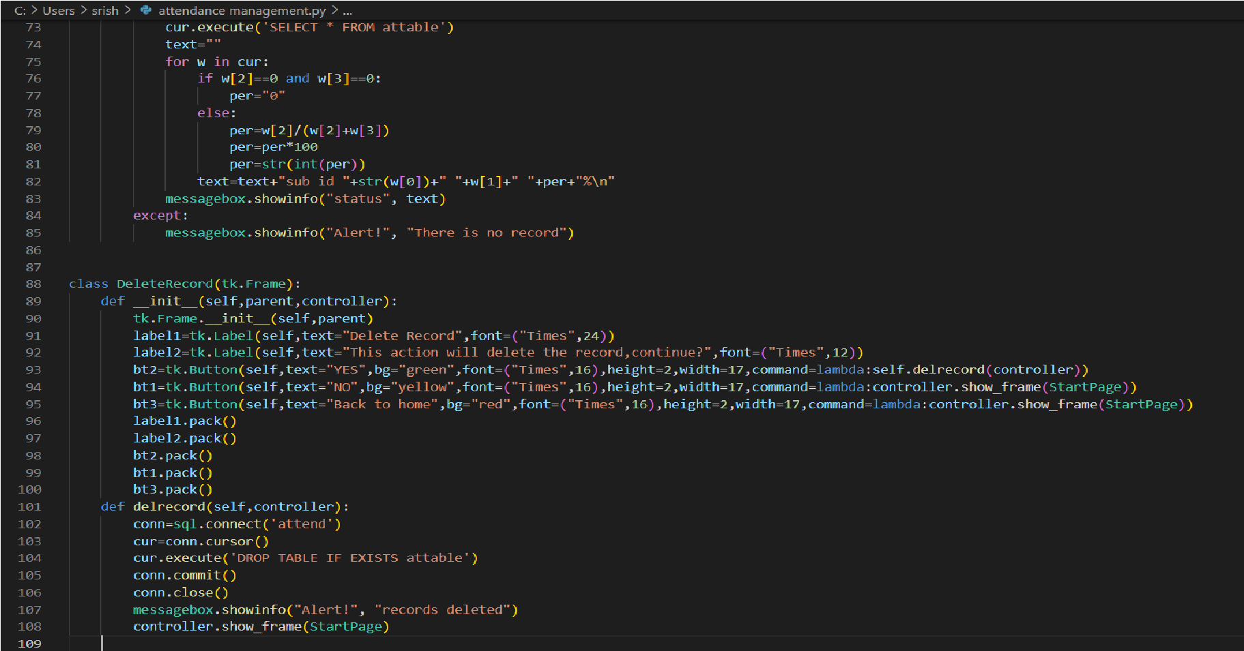

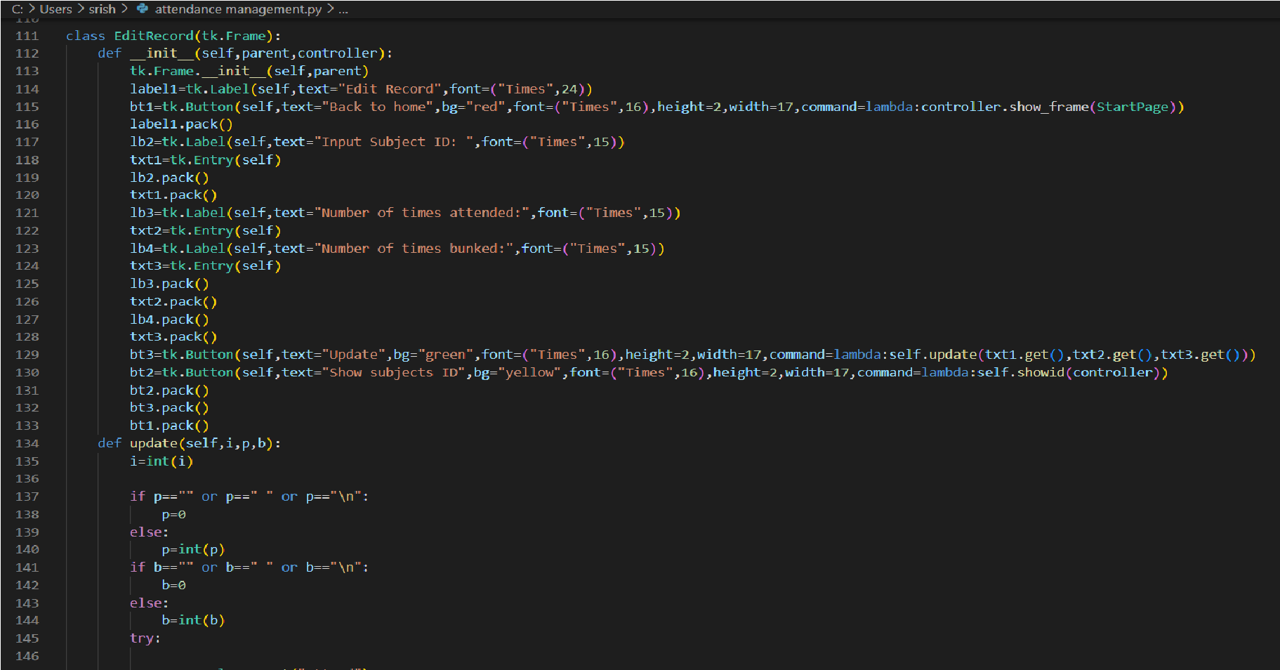

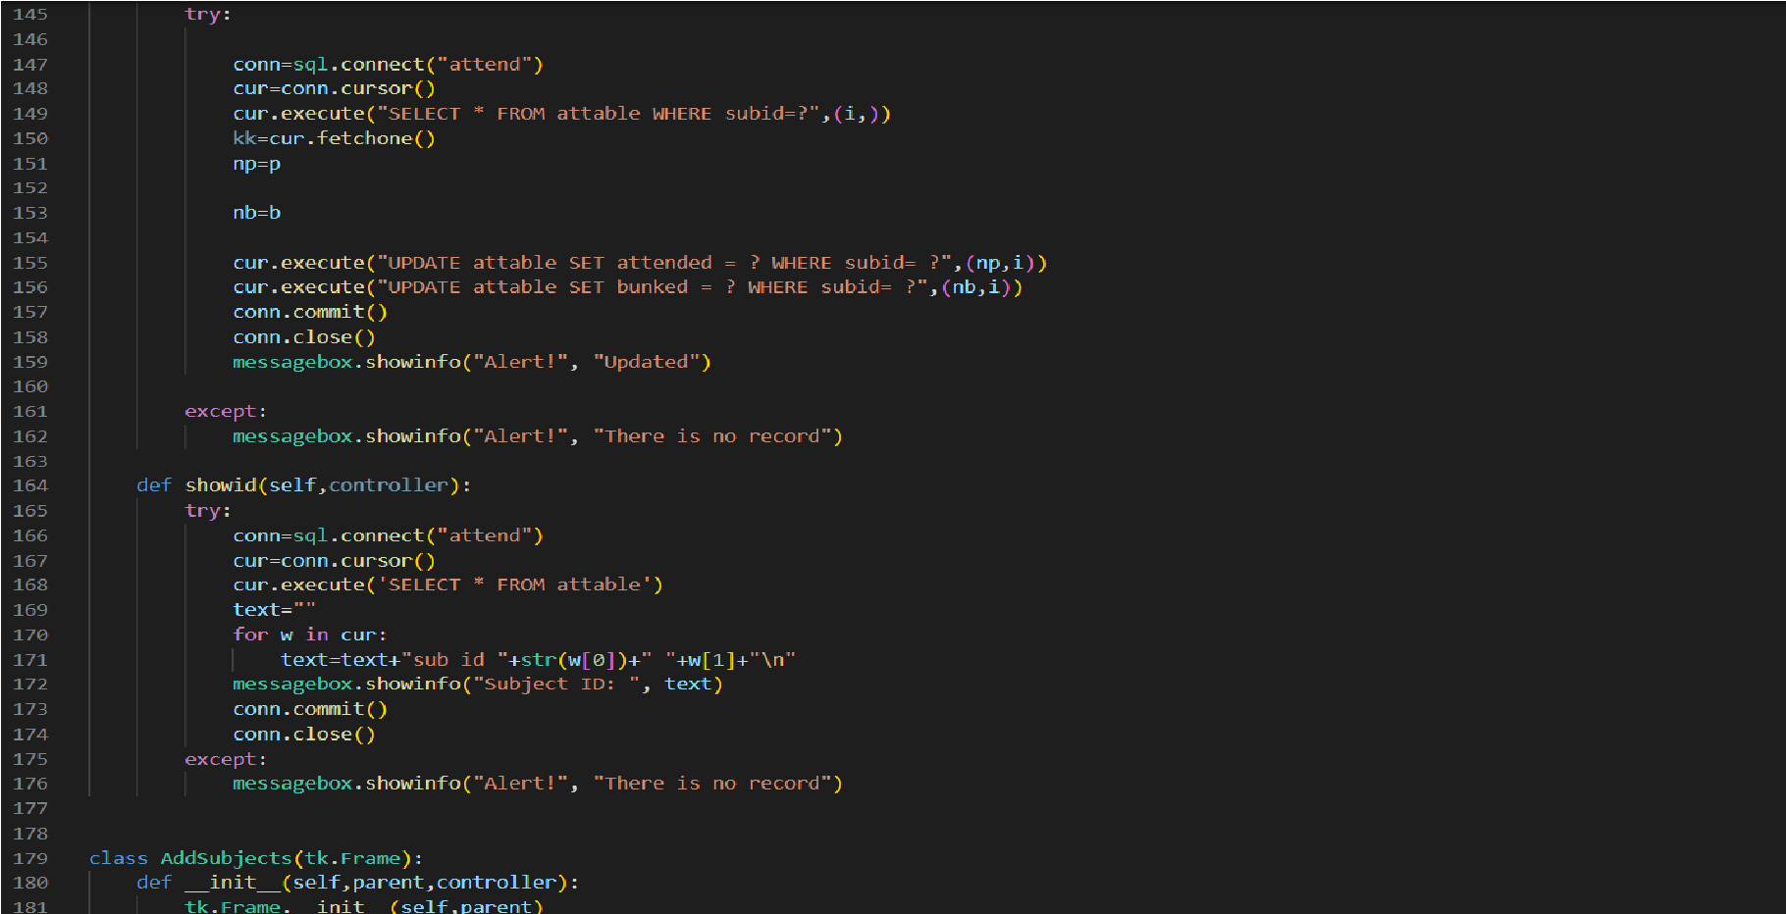

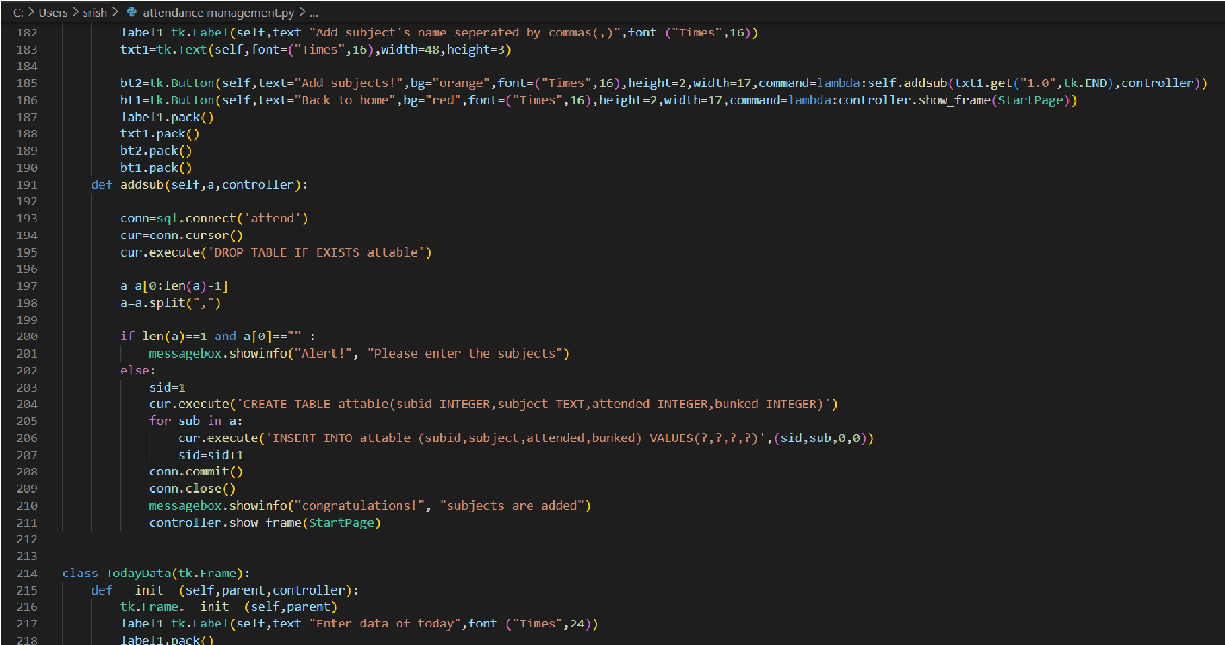

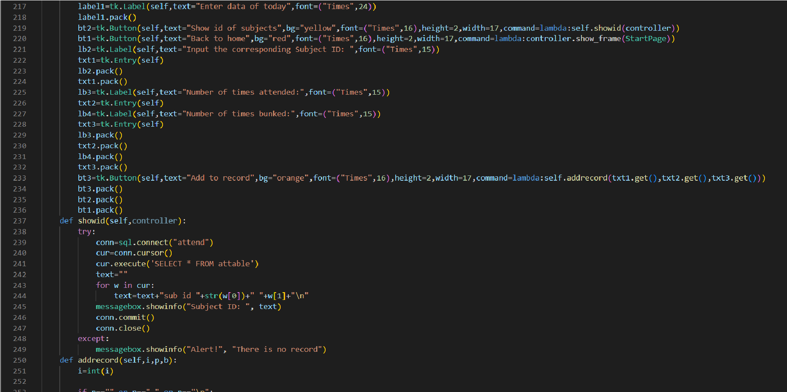

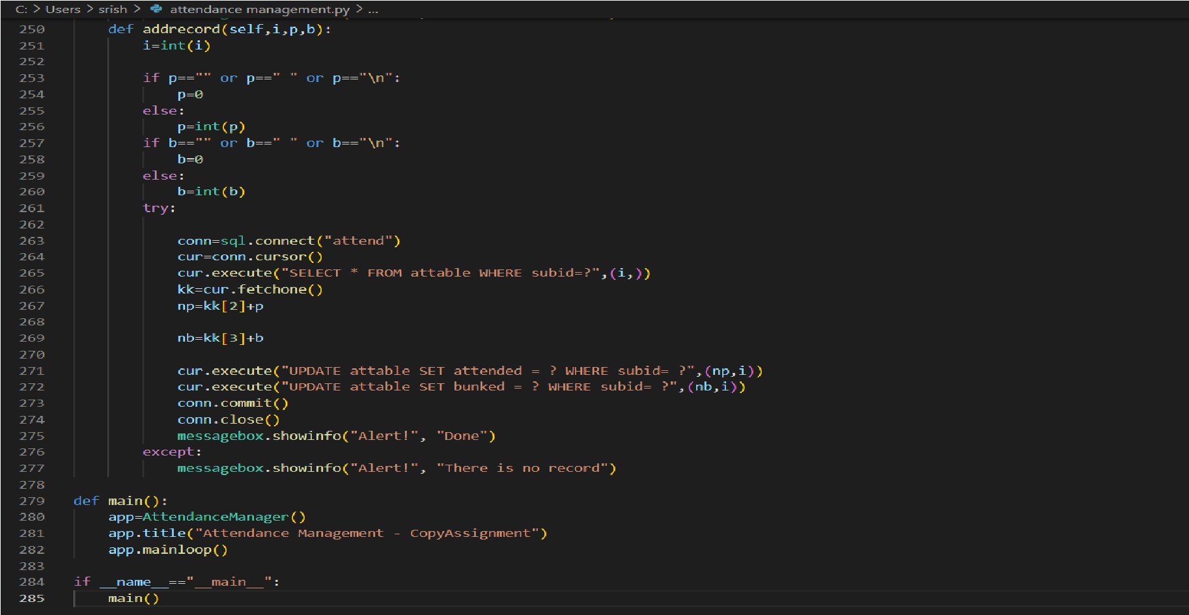

### ` CHAPTER 6 SCREENSHOTS AND RESULTS

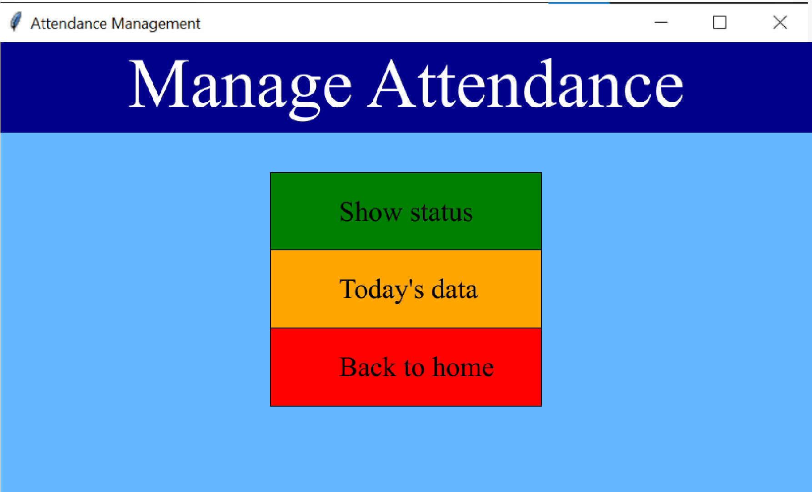

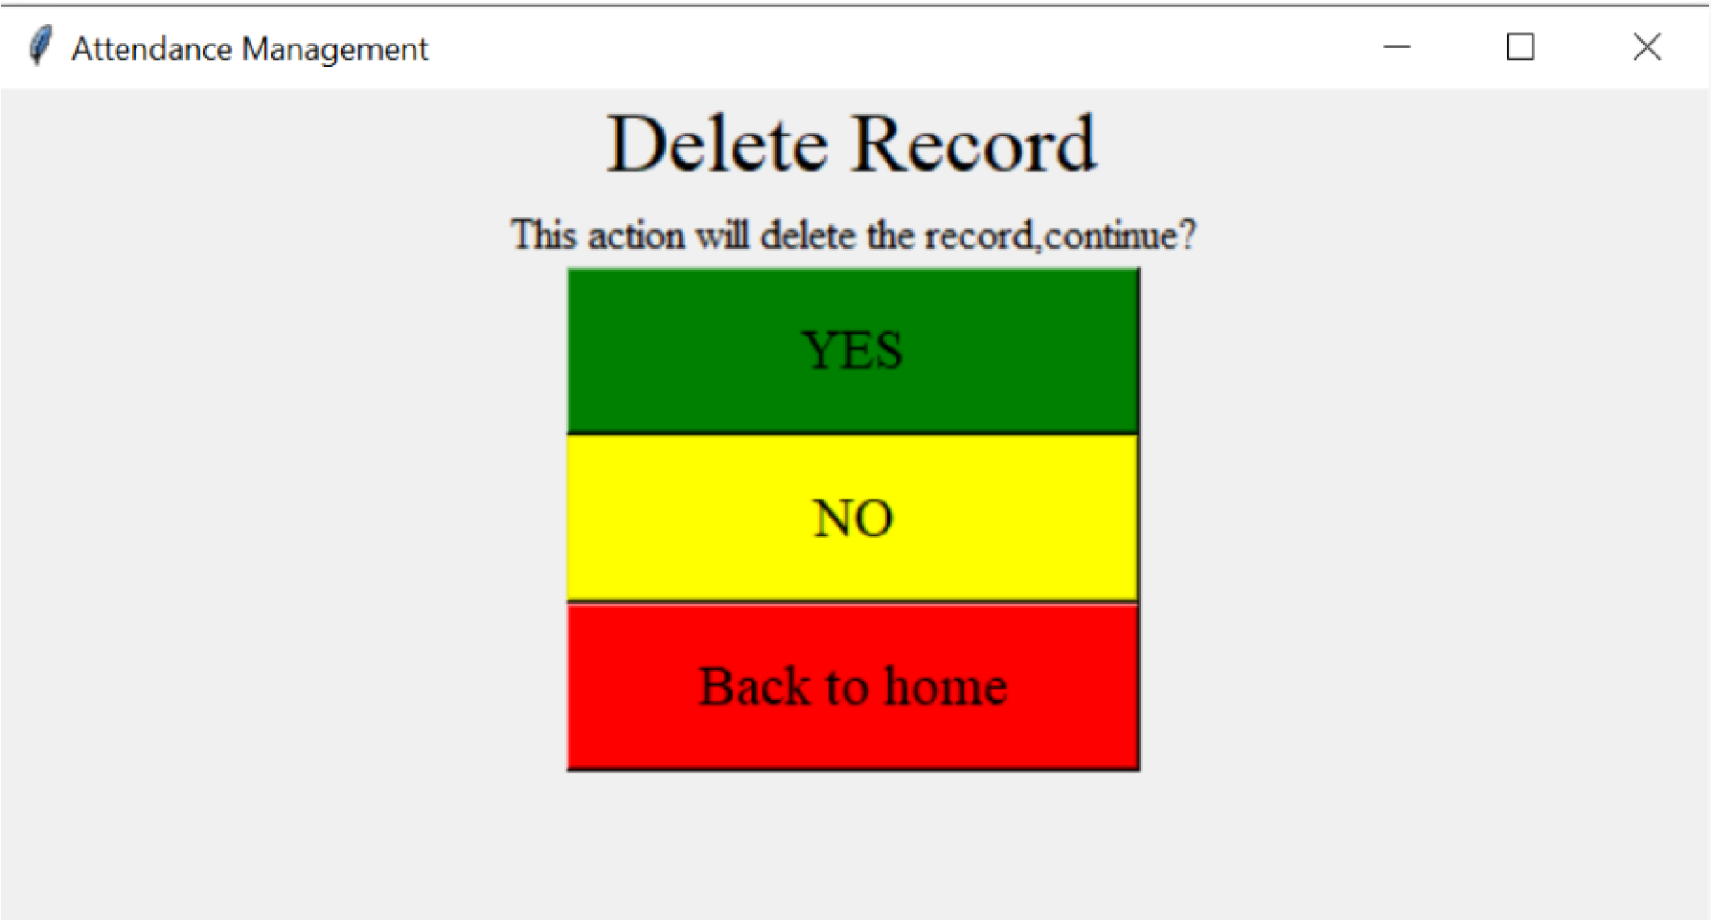

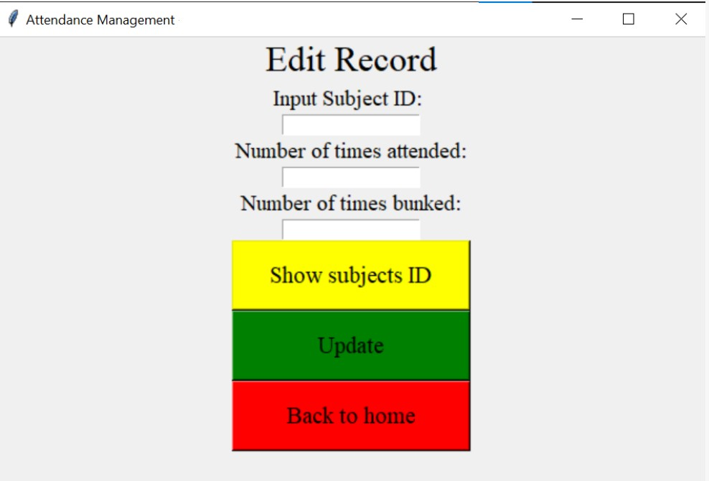

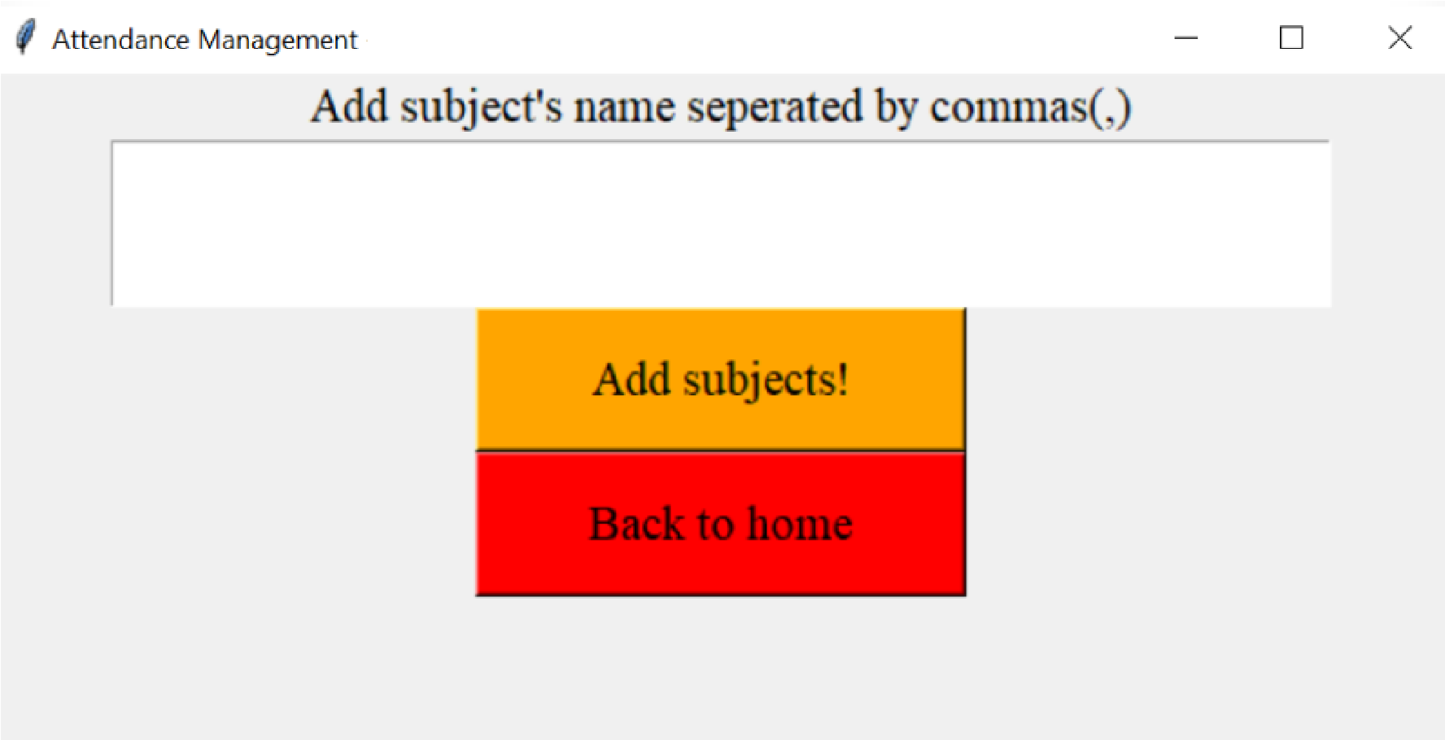

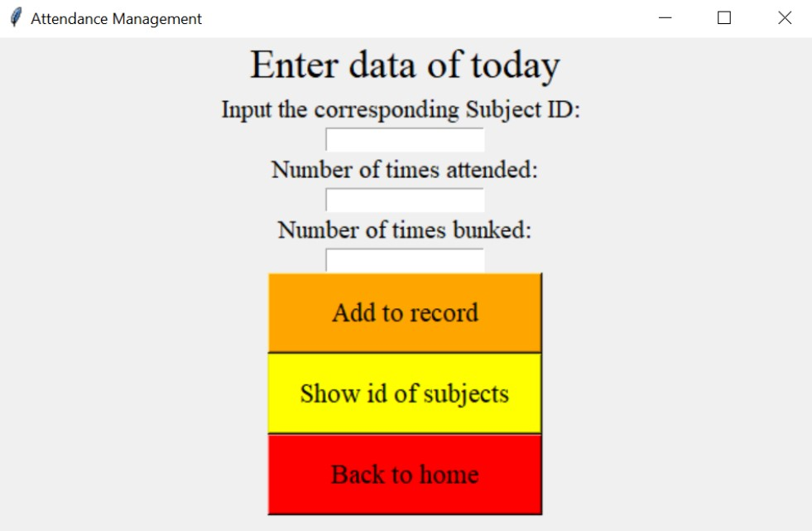

**CHAPTER 7**

### CONCLUSION AND FUTURE ENHANCEMENTS

In conclusion, this project aimed to demonstrate the implementation of a simple attendance management system using Python. The project achieved its objective by utilizing Python's built-in data structures such as dictionaries and functions to manage student attendance.

The program provided the user with three options: to mark attendance, display attendance, or exit the program. When the user chose to mark attendance, they were prompted to enter the student's name, and the program marked the student as "Present" in the dictionary. The program also provided the user with the option to display the attendance status for all students. The project showcased the versatility and simplicity of Python as a programming language for managing small to medium-scale projects. The project could be extended by implementing additional features such as generating attendance reports, integrating with a database, or sending notifications to parents/guardians regarding the attendance status of their wards.

Overall, this project serves as an excellent example of how Python can be used to develop solutions that automate routine tasks, making them faster, more efficient, and less prone to errors. With a few modifications, this project can be adapted to suit different contexts, such as school attendance management, employee attendance tracking, and much more.

### REFERENCES

1. "Developing an Attendance Management System for Educational Institutions," by M. A. Anjum and S. K. Singh. This research paper provides an overview of the design and implementation of an Attendance Management System for educational institutions, including the hardware, software, and database components. Link: https://ieeexplore.ieee.org/document/8637888
2. "Design and Implementation of an Attendance Management System using Biometric Authentication," by I. O. Popoola and O. A. Ojokoh. This paper discusses the design and implementation of an Attendance Management System using biometric authentication, and includes details on the hardware, software, and database components. Link:

https://www.researchgate.net/publication/342803239_Design_and_Implementation_of_an_ Attendance_Management_System_using_Biometric_Authentication

1. "Attendance Management System using RFID," by P. Gajjar and S. Mehta. This paper discusses the design and implementation of an Attendance Management System using RFID technology, and includes details on the hardware, software, and database components. Link:

https://www.ijcaonline.org/archives/volume130/number4/22984-2020918137

1. "Development of an Online Attendance Management System," by R. D. Samsudin et al. This paper discusses the design and implementation of an online Attendance Management System for use in educational institutions, and includes details on the hardware, software, and database components. Link: https://ieeexplore.ieee.org/document/8948897
2. "Design and Implementation of a Web-Based Attendance Management System," by A. H. Al-Tameemi and M. M. Abdulkareem. This paper discusses the design and